2024 YORKSHIRE YOUNG ACHIEVERS AWARDS  BOOKING FORM  Gala Dinner & Awards Presentation  TO BE HELD ON THURSDAY 14 NOVEMBER 2024 AT THE CENTENARY PAVILION, ELLAND ROAD |  | 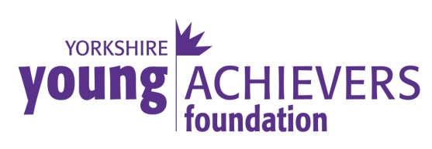  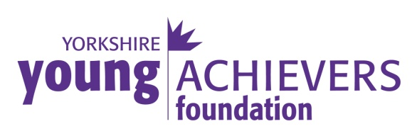
The Yorkshire Young Achievers Awards were established in order to recognise and reward outstanding achievement by young people in or from Yorkshire. Anyone can make a nomination and anyone can be a winner, as long as they meet the requirements.

The winners are decided by a panel of senior members of the Yorkshire community representing different walks of life and Awards are presented at the Gala Dinner.

The Awards, given in the following categories, are open to anyone who was born, lives or works in Yorkshire and is under the age of 35.

AWARD CATEGORIES:
Personality of the Year
Sponsored by Rudding Park

Youngster of the Year (12 & under)
Sponsored by Nabarro McAllister

Unsung Hero
Sponsored by Jamboree Entertainment Ltd

Achievement in Sport
Sponsored by Leeds United AFC

Achievement in the Arts
Sponsored by Mary and Jeremy Carter

Achievement in Education
Sponsored by Harrogate Town AFC

Achievement in Management & Enterprise
Sponsored by CHR Group

Special Award
Sponsored by GMI Property

If you have someone to nominate please visit our website or call Sonia Jones on 01423 530630 for a nomination form. Closing date is Friday 23 August 2024..
Name
Company
Email
Postal Address
Postcode
Telephone No

Please reserve me…….

 | Tickets @ £85 per person
 | Table(s) of ten @ £800 per table
◻ I enclose a cheque for £__________ made payable to “Yorkshire
Young Achievers Foundation”
◻ Please send me an invoice

Please return your form to: Sonia Jones by fax on 01423 537631 or by email to s.jones@mccormicks-solicitors.com or if enclosing a cheque please send to: Yorkshire Young Achievers Foundation, Wharfedale House, 35 - 37 East Parade, Harrogate, HG1 5LQ.

Booking Conditions

Invoices are payable within 14 days of receipt, unless the event is to take place within 21 days of the booking, in which case the invoice is payable by return.

Tickets and/or tables of ten are confirmed only when the invoice is paid for in full.

Cancellation Policy

When tickets and/or tables of ten are booked, the invoice remains payable in full unless the supporter cancels the booking more than 12 weeks before the event.
Get INVOLVED…..

There are a number of ways to get involved with Yorkshire Young Achievers whether as a partner, fundraiser or supporter of the Gala Awards Dinner.

The Yorkshire Young Achievers Foundation raises money through a variety of events and we’re always on the lookout for new inspiration. If you have a fundraising idea or would like to take part in any of our fundraising events then we would love to hear from you.
To find out more about the Foundation please visit the website  www.yorkshireyoungachievers.co.uk  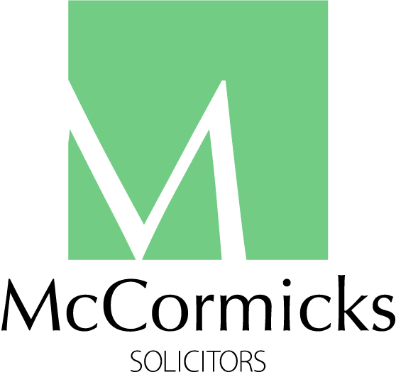 |  | Main Sponsor of the Yorkshire Young Achievers Awards
Trustees: Peter McCormick OBE (Chairman) • Nicola Corp • Martin Gerrard • Sonia Jones • Charlotte McCormick • Richard Stroud MBE (Vice-Chairman) • Zoe Webber
Wharfedale House, 35-37 East Parade, Harrogate, HG1 5LQ. T: 01423 530630. E: info@yorkshireyoungachievers.co.uk. Registered in England Charity No: 1135221. Registered in England Company No: 07161510

