2025 YORKSHIRE YOUNG ACHIEVERS AWARDS  NOMINATION FORM  Gala Dinner & Awards Presentation  TO BE HELD ON THURSDAY 13 NOVEMBER AT THE CENTENARY PAVILION, ELLAND ROAD  Proposer |  | 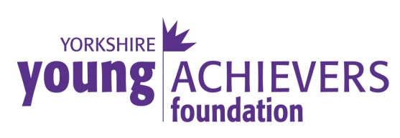  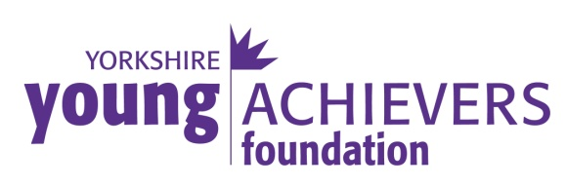
The Yorkshire Young Achievers Awards were established in order to recognise and reward outstanding achievement by young people in or from Yorkshire. Anyone can make a nomination and anyone can be a winner, as long as they meet the requirements.

The winners are decided by a panel of senior members of the Yorkshire community representing different walks of life and Awards are presented at the Gala Dinner.

The Awards, given in the following categories, are open to anyone who was born, lives or works in Yorkshire and is under the age of 35.

AWARD CATEGORIES:
Personality of the Year
Sponsored by Rudding Park

Youngster of the Year (12 & under)
Sponsored by Nabarro McAllister

Unsung Hero
Sponsored by Jamboree Entertainment Ltd

Achievement in Sport
Sponsored by Leeds United AFC

Achievement in the Arts
Sponsored by Articulate

Achievement in Education
Sponsored by Harrogate Town A.F.C.

Achievement in Management & Enterprise
Sponsored by CHR Group

Special Award
Sponsored by GMI Property
If you have someone to nominate please visit our website or call Sonia Jones on 01423 530630 for a nomination form. Closing date is Friday 22 August 2025.
Name
Postal Address
Postcode
Email
Telephone No

Candidate
Name
Postal Address
Postcode
Email
Telephone No
Age on 30 September
Award Category
Details of Achievement
Please help the judges by including as much relevant information as possible. Please continue on a separate sheet if necessary and provide any supporting documents.

Grant Applications: For full details on how to apply for a Grant, please visit our website at www.yorkshireyoungachievers.co.uk or contact Sonia Jones on 01423 530630 or by email s.jones@mccormicks-solicitors.com.

Rules & Conditions: There is no restriction on the number of categories entered but each entry should be on a separate nomination form. Nominations are free of charge. Candidates must be under the age of 35 (12 & under for Youngster of the Year) on 30 September and candidates must live, work or be born in Yorkshire (including the original Ridings) A category may be withdrawn if, in the opinion of the judges, no candidate has achieved the required standard. The closing date for receipt of nominations is 22 August 2025. The decision of the judges is final and no correspondence will be entered into.
To find out more about the Foundation please visit the website  www.yorkshireyoungachievers.co.uk  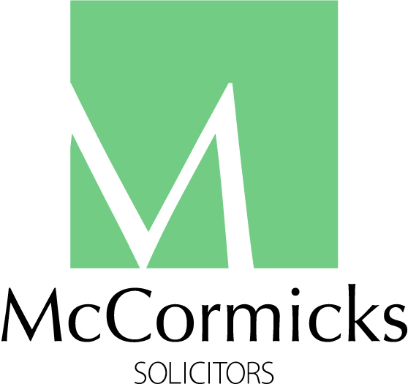 |  | Main Sponsor of the Yorkshire Young Achievers Awards
Trustees: Peter McCormick OBE (Chairman) • Nicola Corp • Jan Fletcher OBE • Sonia Jones • Charlotte McCormick • Dipesh Mistry • Fiona Robinson • Richard Stroud MBE (Vice-Chairman) • Zoe Webber
First Floor, Scottsdale House, Springfield Avenue, Harrogate, HG1 2HR. T: 01423 530630. E: info@yorkshireyoungachievers.co.uk.
Registered in England Charity No: 1135221. Registered in England Company No: 07161510.

